

**AMERICAN INTERNATIONAL UNIVERSITY- BANGLADESH**

**(AIUB)**

**Introduction to Electrical Circuit**

**FALL 2023-2024**

**Section: L, Group: 07**

**LAB REPORT ON**

***To be familiar with the operations of an oscilloscope and measuring corresponding AC quantities from the waveforms obtained from the oscilloscope.***

**Supervised By**

**MD. SHAHARIAR PARVEZ**

|  |  |
| --- | --- |
| **Name** | **ID** |
| **1.MD. Abdullah** | **22-48065-2** |
| **2.Azmir Islam Kafi** | **22-47981-2** |
| **3.Mohammad Ansar Uddin** | **22-47975-2** |
| **4.Chinmoy Guha** | **22-48056-2** |
| **5.Suvra Chakraborty** | **22-48067-2** |

***Abstract:***

The experiment aimed to achieve the following objectives:

1. Acquiring familiarity with the Function Generator and Oscilloscope.

2. Conducting measurements of peak value, peak-to-peak value, average value, RMS value, time period, frequency, and phase difference utilizing the oscilloscope.

**Apparatus:**

1. Function Generator

2. Oscilloscope

3. Probes and Connecting Wires.

***Experimental Procedure:***

1. The output of the function generator was connected directly to channel 1 of the oscilloscope. The amplitude of the wave was set at 10V peak to peak, and the frequency was adjusted to 1kHz, with a sinusoidal wave shape selected.

2. The observed wave shape was sketched on the oscilloscope, and the time period of the wave was determined. Subsequently, the frequency was calculated.

3. The frequency was changed to 2.5kHz, and observations were made regarding the display of the wave on the oscilloscope. This process was repeated with an increased frequency of 10kHz, and wave shapes for both cases were drawn.

4. Measurements were taken for the peak value, peak-to-peak value, average value, and RMS value for all five frequencies. The necessary calculations were performed and recorded in the provided table.

***Result analysis :***

**Table 1:**

|  |  |  |  |  |  |
| --- | --- | --- | --- | --- | --- |
| Frequency (KHz) | Time Period (ms) | *VP-P*  (Volts) | *VP*  (Volts) | *Vavg*  (Volts) | *Vrms*  (Volts) |
| 1 | 1 | 10 | 5 | 3.185 | 3.535 |
| 2.5 | 0.4 | 10 | 5 | 3.185 | 3.535 |
| 5 | 0.2 | 10 | 5 | 3.185 | 3.535 |
| 5.5 | 0.18 | 10 | 5 | 3.185 | 3.535 |
| 10 | 0.1 | 10 | 5 | 3.185 | 3.535 |

***Simulation:  
  
TABLE 1:***

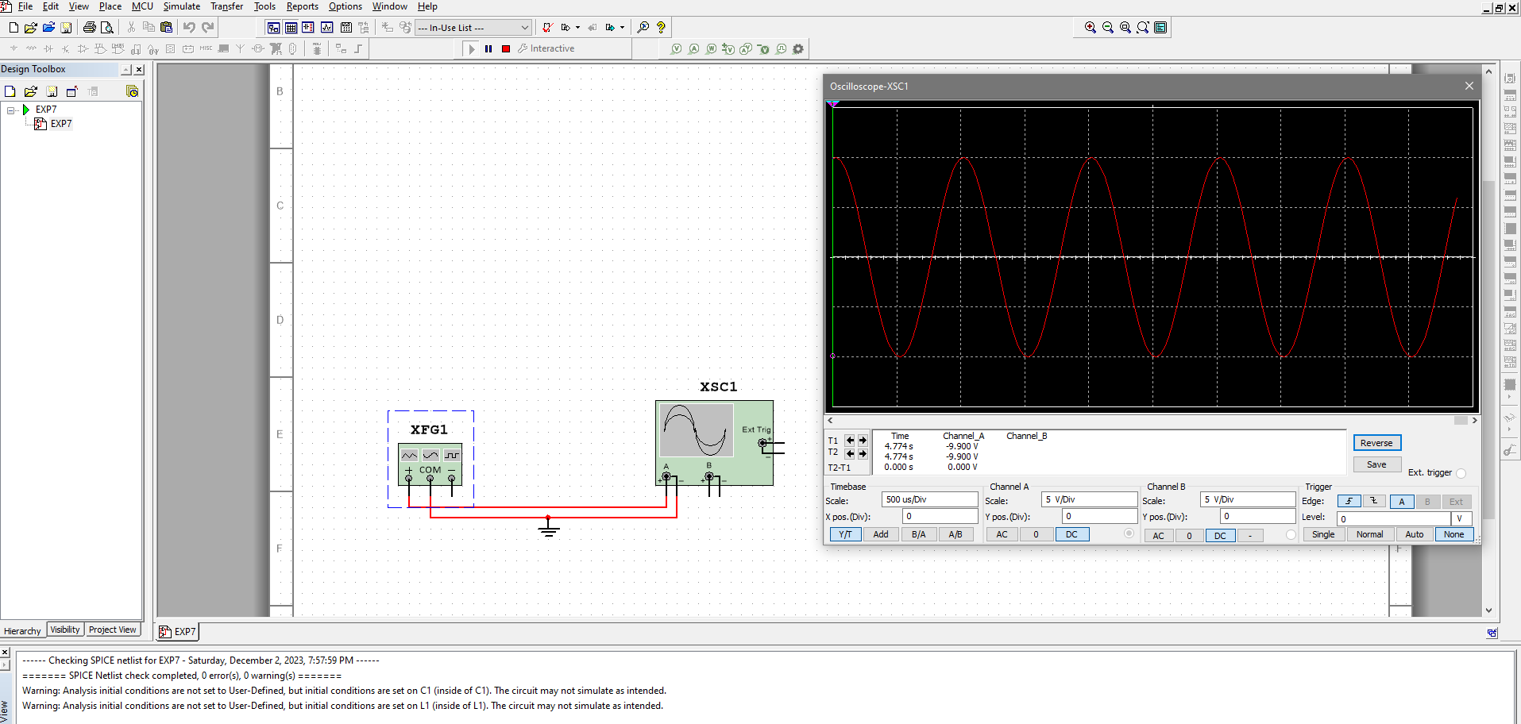

***Figure: For Frequency 1kHz***

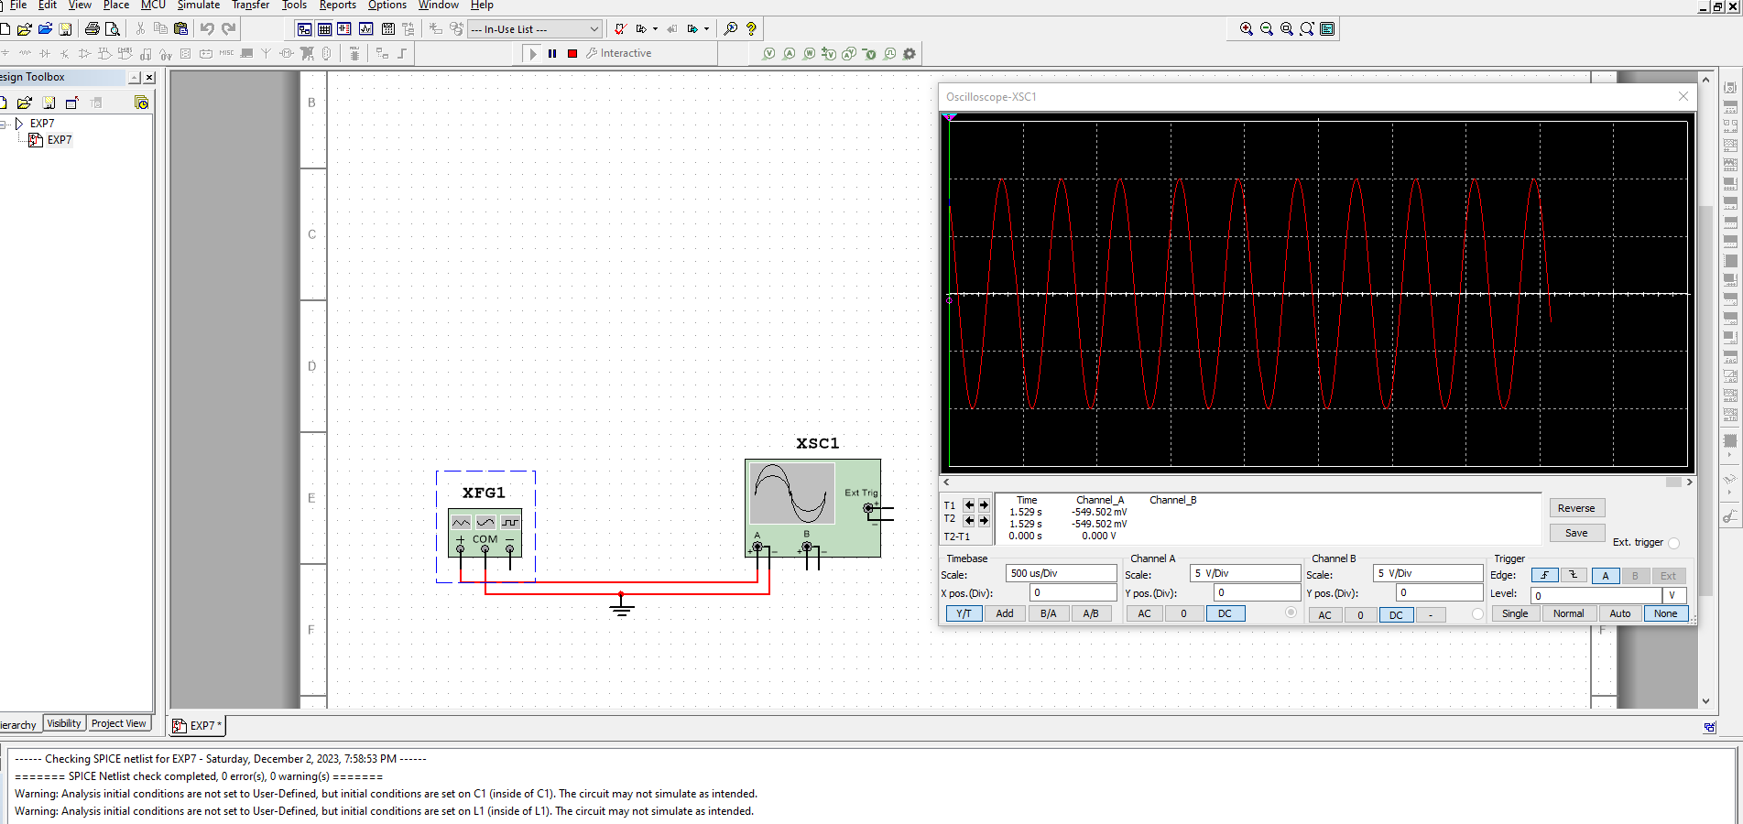

***Figure: For Frequency 2kHz***

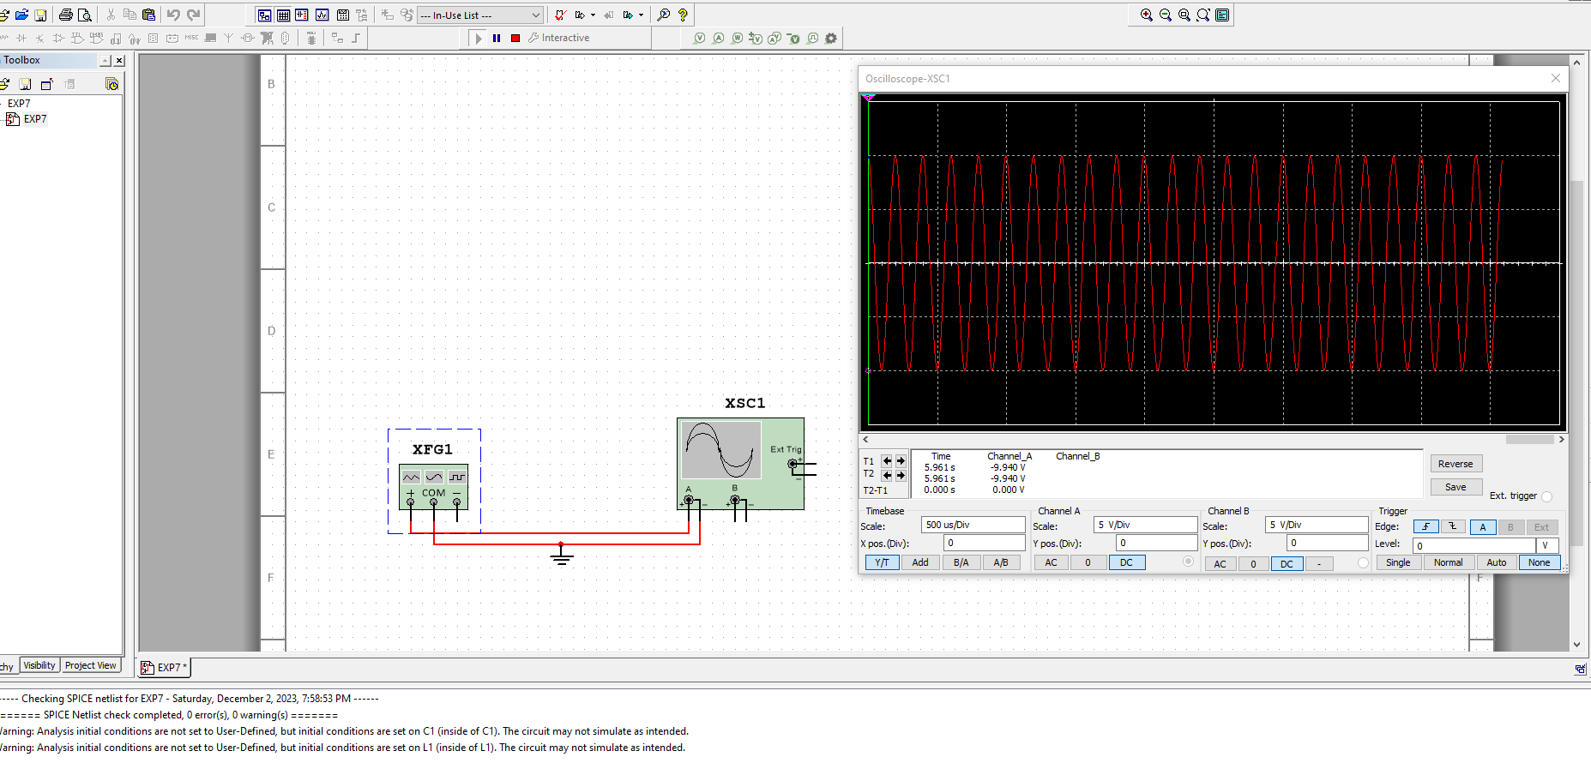

***Figure: For Frequency 5kHz***

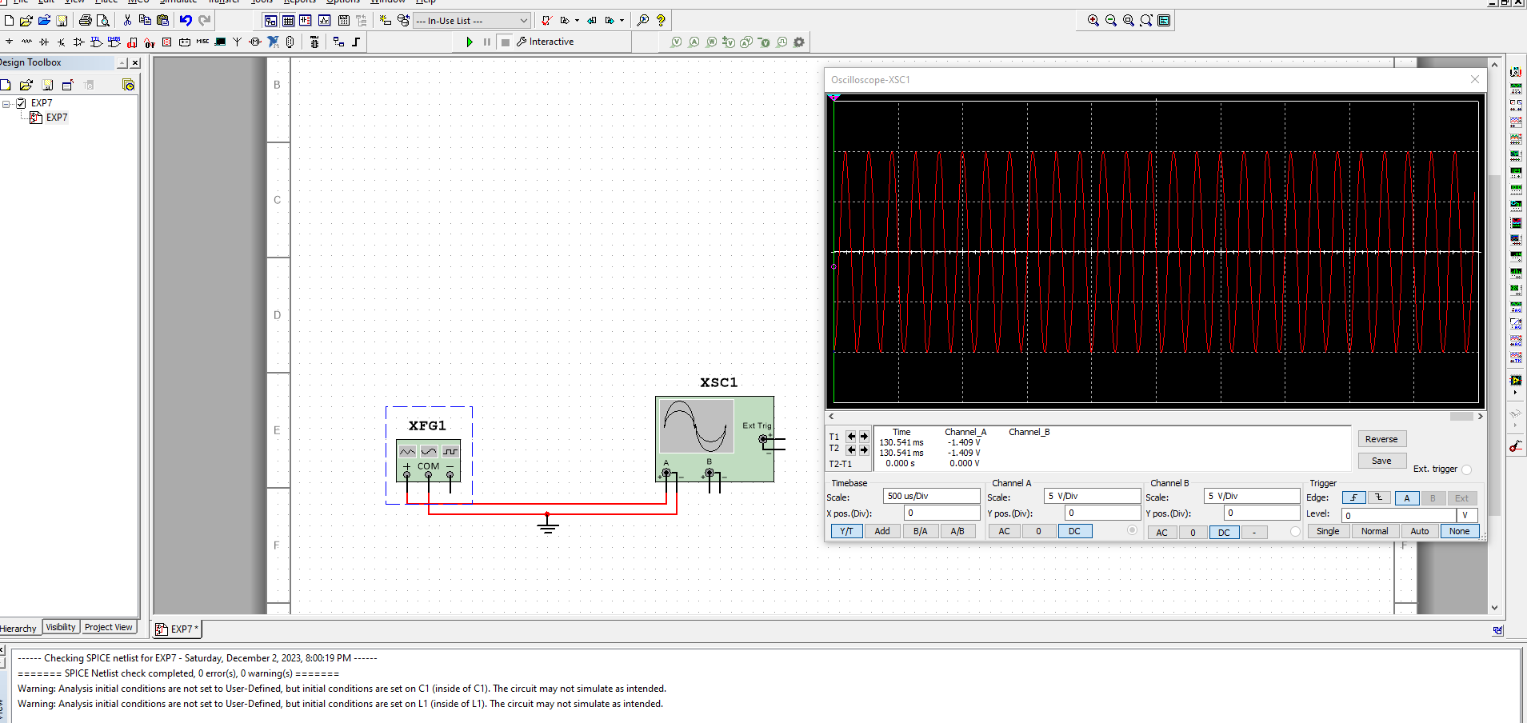

***Figure: For Frequency 5.5kHz***

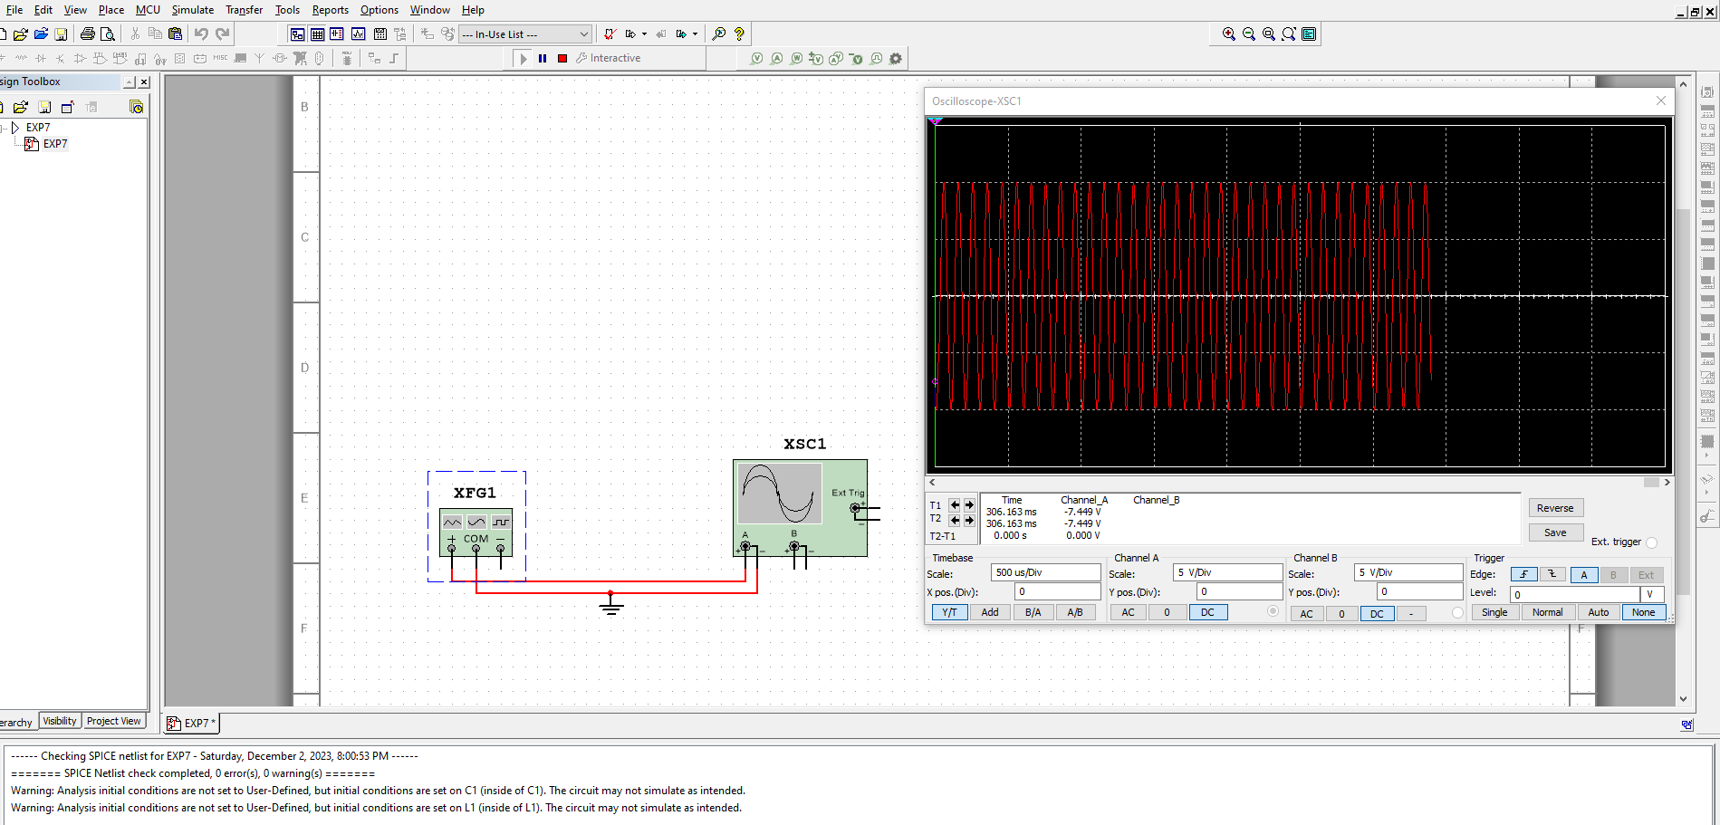

***Figure: For Frequency 10kHz***

***Calculation:***

We know F=1/T

T1=1/F1 = 1/1kHz = 1ms

T2 = 0.4ms

T3 = 0.2ms

T4= 0.18ms

T5 = 0.1ms

Vavg = 0.636 x Vp = 0.636 x 5 = 3.185V

Vrms = 0.707 x Vp = 0.707 x 5 = 3.535V

***Discussion***

The complete experiment was done with Multisim software and the simulation values do match with the calculations that can be done with the formulae.

***Conclusion:***

By completing this experiment we had become familiar with the function generator and the oscilloscope. Measuring the peak value, peak to peak value, average value , RMS value, and time period. We successfully learnt to use the oscilloscope.